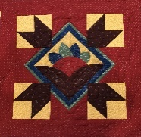
PRAIRIE THREADS
NEWSLETTER OF PRAIRIE PIECEMAKERS March 2020

Hello fellow Quilters,
It is my prayer that this finds you, your family and friends doing OK in this time of uncertainty. Last year we had to cancel meetings in January and February due to weather. This year I had breathed a sigh of relief following the February meeting, (even though I was sick), But we are now in uncharted waters so we will go day by day. Most of you probably already know that the March 30th meeting has been canceled, and we will also cancel the Steering Committee on Monday, April 6th. We will be in touch as to what is to happen down the road.
Please read the newsletter as Sue has taken great care to cover as many areas as possible to bridge the gap. May God Bless your time at home and hopefully those sewing machines are busy. We should have lots for show and tell.
President Pam Schroeder
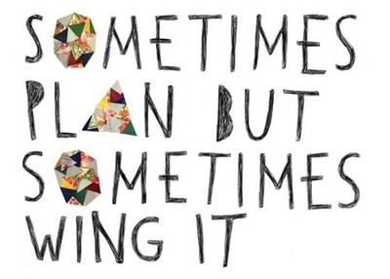
Reminders and Opportunities:
- NEXT MEETING ??????.
- Each I time I think this newsletter is completed and I am ready to hit send, something else changes. We will try to send additional updated information via emails. Pam has been making phone calls to our members that do not have email. If you would like to help with a calling tree, please get in touch with Pam Schroeder. Many hands make little work.
- Challenge Project for this year. The rules/instructions are on page 17 of the Yearbook. It is called "Black and White +1" It may become next year’s Challenge Project????
- Eco-Fair cancelled for 2020. Thank you to those making plans to help or donate project materials. Julie Joyce
- Call your local quilt shops before going. Some have closed to foot traffic.
SUMMER TIME EVENTS FOR YEAR-ROUND PRAIRIE PIECEMAKER FUN!!!
- Prairie Piecemakers Bus Trip June 5 and 6th, 2020. There are a few seats remaining. Registration form in October newsletter. Best information can be obtained by contacting:
- Deb Schroeder 402-380-2626 dschroeder1@unl.edu, 230 South Farragut, West Point, NE 68788 or
Susan Williams 402-440-7853 williamssn1@gmail.com,

Stay tuned for other possible summer events.

- QUILT TAXI (AKA- PICK UP AND DELIVER TAXI)
For the foreseeable future, we are changing our taxi to help any guild member that does not want to venture out of their home and needs a few essential like groceries or medication picked-up. Please let an officer know. We will do everything to help you get the needed items delivered to your door.

Prairie Piecemakers Quilt Guild Meeting February 24,2020
• A very informative presentation on different quilting tools and quilts was given by Sheila Rienke.
• The business meeting was brought to order by Vice President Susan Williams at 8:00
• The Secretary and Treasure Reports were approved and seconded.
• The Taxi service to and from guild meetings and events are still available. Please contact Sue Arp with any questions.
• There are still a few positions open for the Steering Committee for the upcoming year. This is a wonderful way to become involved with your guild.
• Please check your yearbook monthly for Community Service items.
• Hostesses, Greeters, and Door Prize Donations were all thanked.
• Eco Fair is scheduled for April 16th. If you would like to volunteer to present to fourth graders please contact Julie Joyce or Jill Nuremberg.
• You should be working on your yearly challenge to be presented at the end of the year salad dinner. The project should be no bigger than 24” x 24”. We can’t wait to see the imaginations at work.
• The Bus Trip scheduled for June 5th and 6th is now open to non-members of the guild. It’s time to invite family and friends!!
• Plans for the upcoming Quilt Show in October are in full swing. Pat Mommsen presented a new money maker idea for the show called “What’s in the Bag.” Fabric and items such as patterns or notions will be placed in a bag and available for purchase at the Quilt Show. Donations will be accepted at the March, April, and August guild meetings.
• Pat Young has a large cutting table available for free if anyone is interested. Please contact her.
• The meeting was adjourned at 8:30.
• Show and Tell was then presented. Members are encouraged to bring any Log Cabin quilts, big, small, old, or new for show and tell at next month’s guild meeting.
Submitted by Sue Steier, Secretary

The Prairie Piecemakers Steering Committee Meeting March 2, 2020
• Meeting was called to order at 6:30 by President Pam Schroeder. Eleven members were present.
• Ideas for future community service projects were discussed since the Hope Center in Fremont closed. Quilts for emergency services are going to be researched.
• Thirty-four people have signed up for the yearly challenge. There is still fabric available for any procrastinators.
• We are still in need of one more volunteer for the Eco Fair on April 16th. Please contact Julie Joyce or Jill Norenberg with any questions.
• Tables will be set out front at the next guild meeting for next years’ programs, the bus trip, and greeters, holders, hostesses, and door prize donors for next year.
• We are still in need of members to fill in positions on the Steering Committee. We still need a chairperson for the hostesses and we need a member at large.
• Members are encouraged to bring in donations for the Batik Basket and the “What’s in the Bag” both fundraisers for the Quilt Show.
• The meeting was adjourned at 7:30 • Submitted by Sue Steier, Secretary

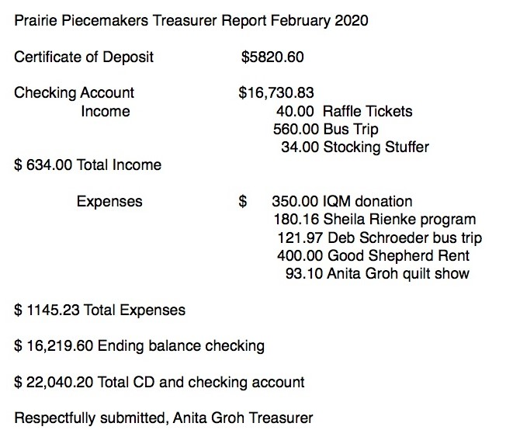
Community Service -Jan Larsen
Due to cancellations of our meetings, community events and community outreach centers (many have closed their doors previous to the Corona virus and Jan has been busy checking out other alternative community projects) ; we ask that you consider doing your community service by helping each other, your neighbors, your friends, your families, anyone in need.

The 2020 Star-Studded Quilt Show is still a go. Planning will just be done in a different format than face to face meetings. Thank goodness for phones, email, texting, scanners, etc. I never thought those words would be coming from me, one of the last holdouts on text messages and smart phones. Shop hop has been expanded from March to June, so there is additional exposure for our raffle quilt. Our show should have some wonderful quilts as our members create masterpieces during the “quarantine.” Stay strong, stay busy, and stay positive. Sue Arp

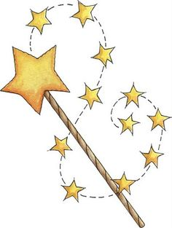
WISH LISTS: Ladies, 69 batik Fat quarters still needed. We will be collecting them at our next in-person gatherings. Thank you so much in advance. Julie Joyce

WHAT’S IN THE BAG WISH LIST: (Locked in???sort through your drawers for some of the following needed treasures)
See through bags will contain either a precut, or three yards of coordinating fabrics. Just like the fishing pole game at carnivals, there will be a fun surprise hidden in each bag with the material. It could be a pattern, a notion, an embellishment, etc. Donations will be accepted at the April and August guild meetings. Thank you. If you need more information or have questions, call Pat Mommsen, 402-625-2109 or 402-669-9119.

Charm Packs-two of a kind
Jelly rolls
Layer Cakes
Yardages: one-yard cuts of the following
Patriotic Prints
Christmas Prints
Halloween Prints
Autumn Prints
Batiks
Red and White Prints
Blue and White Prints
Black and White Prints
Modern Prints
Blenders
Neutrals

Notions: Pins, tape measures, marking pens, small rulers, etc.
Embellishments: Fun Buttons, rick rack, etc.
Quilt Show Committees to Date:
Quilt Moms: Vicki and Nicole Japp
Vendor: Sue Williams
Kitchen and Red-Carpet Café: Teri Wolfe and Pam Schroeder
Fat Quarter Basket: Julie Joyce
Admissions: Lisa Braasch, Anita Groh, Sue Steier
Silent Auction/Basket Bonanza Marilyn Bonow and Jill Norenberg
Publicity: Deb Schroeder
What’s in the Bag Pat Mommsen
Featured Quilter Bert Cowles
F. Q. Reception/Set-Up Sue Steier, Anita Groh, Lisa Braasch
Treasurer Lisa Braasch-new, Anita Groh-past
Decorations: Everyone-direction by Marilyn Freeman
White Glove/Viewer’s Choice Wanda Kruger
Quilt Registration Sue Arp, Susan Williams

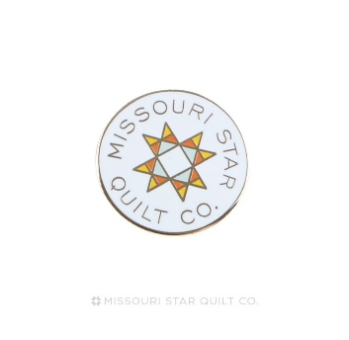

- Lorraine Smith displayed our quilt at a retreat in Okoboji. Sales were great and she wrote, “And one of the ticket buyers was Jenny Doan - how fun was that!” Just a reminder…Jenny Doan is the founder of Missouri Star Quilt. Our bus trip destination.

Next year’s presidents, Susan Williams and Deb Schroeder have been super busy planning for the upcoming year. They already have numerous programs and events planned and wanted to give you a preview of what is in store. After reading the many fun things available, please complete your membership form, located at the end of the newsletter, and send it with your payment to:
Jill Norenberg, Membership Chairman 2020-21
2506 East 10th St., Fremont, Ne. 68025

Make checks payable to: Prairie Piecemakers.
Please take time to do this as soon as possible. If we get to meet in April, we will have more time to socialize with less business to done. Everyone will be ready to relax and enjoy.

Mark Your Calendars for Summer and Fall Quilting Fun

We have several activities planned for this summer and some great programs for next fall. It is always fun to get together with quilting friends. We hope you plan to attend our regular monthly meetings featuring great speakers and a brief business meeting.

We also hope you will choose to attend a workshop, tour, event or sew day. More details on locations and times will follow in April. We will have sign-up sheets at the April Meeting. Mark your calendar today:

May, 24, 2020
BBQ and Benefit Sewing – Join us on May 24, 2020 for a day of service sew and the first BBQ picnic (indoors) of the year. The food will be great and the fellowship will be priceless. Time, location and service project to be announced.

June 5- 6, 2020
Star Studded Affair Bus Trip – We are headed to Missouri Star Quilt Company in Hamilton MO and after a night in St Joe we will stop at Top Stitch Quilt Shop in Helena, Crossroads Quilting in Cameron, MO and Needles I in Auburn, NE. If you want to be on the waiting list to attend contact either Debra Schroeder (402-380-2626 or Susan Williams (402-440-7853).

July 26-27, 2020
Christmas in July – Get a head start on your Christmas gifts and share ideas with friends. Bring your projects, a sack lunch and a dozen cookies to share. We will sew 2 pm to 8 pm on July 26 and 9am to 4pm on July 27. Location TBA

August 31, 2020
Trunk Show Anne Wemhoff – will give a Trunk Show at our regular August meeting. Anne is the owner of Calico Annie’s Quilt Show in Fullerton Nebraska.

Workshop – Anne will be teaching a workshop the afternoon of August 31, featuring some of the latest patterns and techniques from her shop. We will have details and sign-up sheets at our April meeting.

September 28, 2020
Make Extraordinary Scrap Quilts Diane Volk Harris will be our presenter for the September meeting. Diane is a national speaker who lives in Bladen Nebraska. You can see her work on her website https://stashbandit.net/ .

Bound for Glory Do you dread binding a quilt? Do your edges give you less than a fine finish? Solve all your binding woes here! You will enjoy learning as Diane Volk Harris teaches unique ways to finish your quilts. Learn the hints, tips and tricks to perfect binding every time. We’ll cover everything from cutting to bias to corners and even show you a mock-hand binding done completely by machine. You’ll never balk at binding again! (cost $20.00).

October 9, 2020
Threads Across Nebraska We are planning to carpool to Hastings Nebraska for Threads Across Nebraska State Quilt Guild Meeting to support two of our guild members. Scott Flannagan will be the Featured Quilter at Threads and Karen Ruwe is this year’s State Quilt Guild President. We will take sign-ups and volunteers for drivers during the August and September meeting.

October 16-17, 2020
“A Star-Studded Affair” Quilt Show will be held Friday and Saturday. Keep working on those quilts to show, sign up to work and be sure to get your raffle tickets to sell.

October 26, 2020
Help, I Can’t Find It Organizing Your Fabric and Tools - Sandi Griepenstroh from Central City will be our featured speaker. Sandi will help you create systems that will work to tame the clutter, and organize your things in a way that makes sense and is easy to maintain. Most importantly, she shows you how Mari Kondo’s methods of “tidying” will help you get on top of your stash and be able to use it rather than simply accumulating an ever-increasing and unused “collection” of fabrics!

Perfect Peels Workshop Learn several possible sizes and applications for the simple orange peel shape! Just two charm packs and a half day are enough fabric and time to make a simple orange peel table topper or runner. You will learn fusible applique, as well as other ways to use this versatile shape in the class. Cost $20.00 Bring your own material.

November 30, 2020
What’s New in the Market Place – Susie Brown owner of Calico Cottage in Hastings NE will share tips on new rulers, fabrics and patterns. See some of Susie’s latest quilts. You are sure to learn a new technique or tip that will make your quilting more fun.

Crazy Christmas Tree Table Runner Susie will help us get ready for the holidays by teaching us Karla Alexander’s Crazy Christmas Tree pattern using the Creative Grids Spider Web Quilt Ruler. We are sure to have fun. Cost $10.00 plus ruler. Bring your own material.

December 14, 2020
Christmas Brown Bag Party – Join us for our second annual Brown Bag Christmas Party. In August you will get a brown bag. Place 4 fat quarters inside the bag and bring it to the September meeting. At the end of the meeting you will receive another member’s brown bag to take home and create a project of your choice to return to the owner during the Christmas party. Location TBA

PRAIRIE PIECEMAKER MEMBERSHIP FORM 2020-2021
Last Name: ______________________________________________
First Name: ______________________________________________
Address: ______________________________________________
City, State, Zip: ______________________________________________
Preferred Phone: ______________________________________________
Email address: ______________________________________________
All newsletters will be sent via email to save money and keep our dues the same as previous years. If you have no email, we will send via mail. If you have address labels and can supply, it makes the mailing process easier.

Guild Opportunities: Be a hostess, a greeter, a quilt holder or bring a door prize. Please list the month(s) you would like to serve. Months range from August to April. You may sign up for more than one opportunity.
Hostess: Month(s):
Greeter: Month(s):
Quilt holder: Month(s):
Door Prize: Month(s):

Annual dues are $20.00 if paid prior to May 1st.
They are $25.00 if paid after May 1st.
Return completed form to:
Jill Norenberg, membership chairman, at 2506 East 10th St. Fremont, Ne. 68025 or
Prairie Piecemakers. P.O. Box 1202, Fremont, Ne. 68026-1202

