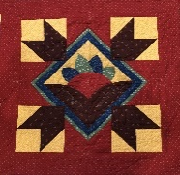
PRAIRIE THREADS
NEWSLETTER OF PRAIRIE PIECEMAKERS September 2019

Enjoyed the first meeting back from the summer break. It was fun to hear the buzz in the room as everyone caught up with each other. About 70 were in attendance with several guests, members and new members. Great food, great door prizes, great program, great friendships. It’s destined to be a great year. See you at the next meeting.

Welcome to New Members: Please add these members to your yearbook. For ease, just print, cut and paste in your book.
Danielle Smith
7726 N. 281 Ave.
Valley, Ne. 68064
316-708-5549
dansmith61@cox.net

Connie Hineline
3905 N. 157 St.
Omaha, Ne. 68116
402-520-0435
cjdux@diodecom.net

Therese Hoyle
1138 Elizabeth Cir
Fremont, Ne. 68025
402-874-1105
hoyle.therese@gmail.com

Corrections to yearbook:
Page 20 Council Bluffs, IA. Not MO.
Page 30 Delores Bang change of address to 655 W.23rd, Apt. 615, Fremont
Page 31 Colete Garton cross through 402-720-8578
Page 33 Faith Perry change email to faithquilt1@gmail.com
Page 34 Elizabeth Stark change email to stark.e123@yahoo.com

Reminders and Opportunities:
- NEXT MEETING SEPTEMBER 30TH. CHECK YOUR YEARBOOK PAGE 9. ARE YOU A GREETER, A HOSTESS, SUPPLYING DOOR PRIZES, HOLDING QUILTS? WHAT ARE YOU NEEDING TO BRING FOR OUR COMMUNITY SERVICE?
- Bring brown bag with fat quarters if participating in Christmas Brown Bag. Page 12 yearbook.
- Bring Quilts to Karen Ruwe for Threads Across Ne. display. She needs these by Oct. 8. Call her if questions. Register your quilt on line at www.nsqg.org
- Karen will have raffle tickets available for the quilt she made for Nebraska State Quilt Guild.
- Cottonwood Quilters Guild will have their quilt on display with raffle tickets for sale prior to our September meeting. We plan to share our quilt with their group at a later date.
- Challenge project material (a 10” square) will be handed out in October. Page 17 yearbook.
- Get your retreat forms completed and turned in. Attached is a registration form.
- Our 2020 quilt show Raffle Quilt will be on display in November. Your tickets will be ready to pick up at that meeting. If we all buy and then sell our 10 tickets, we can continue to keep our dues in check and have great speakers. Thanks in advance. Your cooperation is greatly appreciated.

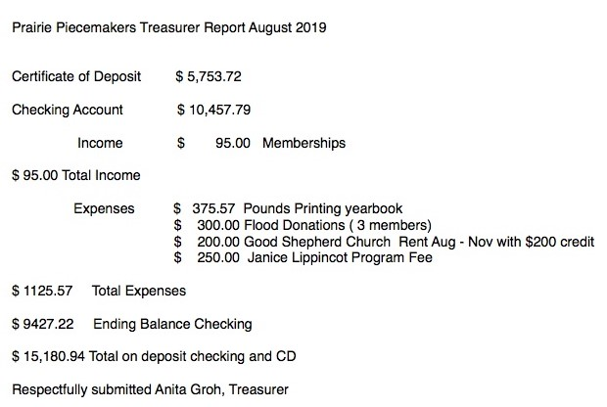

Prairie Piecemakers Quilt Guild Meeting August 26, 2019
• Janice Lippincott presented a wonderful program Focusing on the Bargello style quilt.
• the Secretary and Treasure Report were approved and seconded
• Yearbook corrections were made by all present
• If anyone has anything, they would like included in the newsletter it needs to be to Sue Arp 10 days prior to the next guild meeting
• The new microphone system is in route and will be available at the next meeting.
• Threads across Nebraska is the second weekend in October. Please go to their website for registration and more information. You are encouraged to show one of your own quilts in this show. If you are interested please contact Karen Ruwe.
• Members are invited to participate in the optional activities for this upcoming year. Please see the yearbook for more information.
• The Quilt Show committee is looking for a Quilt Mom. Please consider this position. For more information contact Sue Arp or Marilyn Freeman.
• Thank you to all the greeter, hostesses and those who donated door prizes.
• Meeting adjourned at 8:20 Respectfully recorded by Sue Steier, Secretary

Prairie Piecemakers Steering Committee Meeting September 3, 2019
• Meeting was brought to order at 6:30 by President Pam Schroeder. There were 7 members in attendance.
• Changes to the Yearbook and new member information will be shared in the Newsletter each month. • Sign-up sheet for the trip to IQM will be passed out at the September guild meeting. We will meet at the Good Shepherd Church and carpool together.
• The preparations are in full swing for the upcoming quilt retreat. Members are encouraged to sign up for this fun event.
• Information about the Bus Trip in June will be announced at the September meeting.
• The Star-Studded Affair Quilt Show is still looking for a Quilt Mom. For more information contact Sue Arp or Marilyn Freeman. The Featured Quilter for the Quilt show has been selected and will be announced at the September meeting. A motion was made to increase the price of the raffle ticket from $1.00 to $2.00. Each member of the guild is required to sell 10 tickets for a total of $20.00. The Motion was First and Seconded and approved.
• Threads Across Nebraska is wanting quilts to display at their show. If interested contact Karen Ruwe.
• A committee has been formed to redo the bylaws for Prairie Piecemakers. It consists of Scott Flanagan, Sue Steier, and Kathy Murphy.
• Meeting was adjourned at 7:40 Respectfully submitted by Secretary, Sue Steier

Community Service Update-Jan Larsen
Thank you to everyone that brought items or checks for LifeHouse. They were very appreciative and sent a letter describing how LifeHouse was able to help an individual transition from LifeHouse to an apartment of his own.
For September, please bring school supplies such as Notebooks, Dry Erase Markers, Crayons and Kleenex to help out at Washington school. They will be distributed to help students who cannot provide their own.

Our Christmas Stocking Workday is October 28th from 2:00 - 4:00 at Good Shepherd Lutheran Church. We plan to make 75 or more stockings.
- Bring Christmas fabric to make stockings to the September Mtg
- Bring monetary donations to help fill the stockings.
- Sign up if you can come and help sew or cut on October 28th.
Watch for an update about the Pin Cushions for the International Quilt Museum in Lincoln. Word has it that we only have until December to contribute homemade pin cushions for their project. There will be a basket to put them in at the meeting.

Get Wrapped Up in the FUN Prairie Piecemakers’ Retreat 2020
Friday, January 10, 2020
9AM-5PM
Saturday, January 11, 2020
9AM-4PM
At Country Traditions in Fremont
Hosted by “The Loose Threads”

First Name_______________________________Last Name_____________________________
Address:_______________________________________________________________________
City:___________________________________________State:______________Zip:_________
Phone number:____________________________Email address:_________________________
Member- 2 days………………………. $50.00 __________
Member-1 day…………………………. $25.00 __________
Non-member-2 days…………………$65.00 __________
Non-member-1 day……………………$30.00 __________
Food Allergies: __________________________________________
Lunches, snacks, and pattern notebook included. Pattern notebook passed out at November guild meeting. Surprise Project ideas “unwrapped” at retreat. Fun door prizes for ALL.

Retreat Limited to 48 participants. REGISTER NOW. You do not want to be left out!
Deadline registration for Prairie Piecemakers ONLY is November 25, 2019. After our November guild meeting, registration will be open to non-members. All registration will be closed on Jan.1, 2020.

SORRY. THERE WILL BE NO REFUNDS, but you can send someone in your place.

Return completed registration form with payment to:
Leslie Thompson
9115 Adams St.
Omaha, Ne. 68127
If questions, call Leslie: 402-630-4581

Make checks payable to: Prairie Piecemakers

