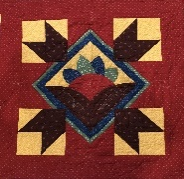
PRAIRIE THREADS
NEWSLETTER OF PRAIRIE PIECEMAKERS October 2021

Dear Prairie Piecemakers Members,
Fall is here! I hope that you are enjoying the changing of the colors and the beautiful weather. As we gain inspiration from the colors of nature, hopefully you have plans to begin a new project or finish a project. Our Monday October 25, Guild meeting will spark your creative side and expose you to new techniques. We will gather for refreshment at 6:30 p.m. and the program at 7:00 p.m. with meeting to follow. If you are not able to attend in person, join us on the members only Facebook page at: Prairie Piemakers Fremont Quilt Group.
Our October speaker is Liz Granbery-Jerome (Designer and National Speaker), from Baldwin City, Kansas. She is a designer, teacher, custom quilter and owner of Gypsy Dreamer Quilts. Liz made a name for herself by creating the Hexified Panel Quilt, which is a twist on the One Block Wonder technique. Hexified Panel Quilts use seven quilt panels. Six panels are turned into hexies that are color-flowed around the seventh panel. Liz has made over 50 Hexified Panel Quilts and One Block Wonder variations, had several quilts published in One Block Wonders of the World (2017) and One Block Wonder Panel Quilts (2021), and is a guest quilt artist making Hexified Panel Quilt samples for Timeless Treasures Fabrics. Liz has taught her workshop across the heartland states, California, Missouri Star Quilt Company, and taught at the 2017 and 2019 Kansas City Regional Quilt Festivals.
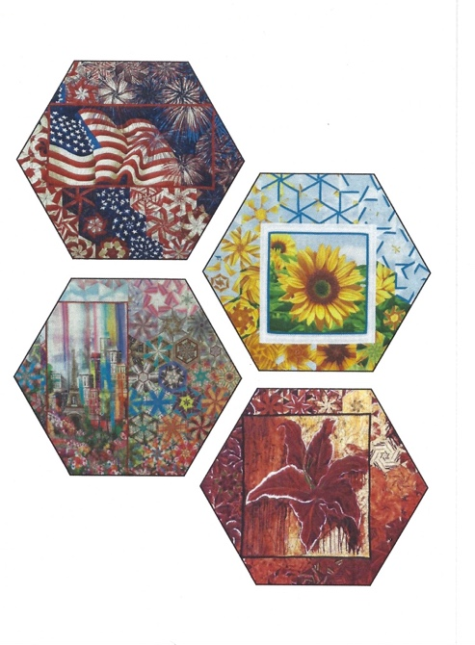
You can find out more about Liz at: GypsyDreamerQuilts.com
Liz Granbery-Jerome will teach a workshop on creating mini hexies on Monday and Tuesday 10/25-26. You will be able to learn the techniques and finish a small wall hanging with the kit that she has available. The two-day workshop will be held at Nebraska Quilt Company (Country Traditions) in Fremont. This is the first time that Liz has taught her techniques in this area. The two-day workshop is a real bargain at $30 for members and $40 for non- members of the Guild. Liz has kits available to purchase at $25 or $35 depending on the size of project that you want to create. You will be able to choose your kit at the first part of the workshop. You can bring your own panels. For more information on the workshop and to sign up contact: Susan Williams at 402-440-7853 or williamssn@gmail.com or Debra Schroeder at 402-380-2626 or dschroeder1@unl.edu.

Congratulations Scott Flanagan who was the featured Quilter at 2021 Threads Across Nebraska. We hope that several of our members were able to attend and celebrate with Scott and all his accomplishments. Scott we are so pleased to have you as a member of our Guild and thank you for all you do for us.

Points of Interest
- October 20, sew day for charity at Nebraska Quilt Company Noon – 4:00 p.m.
- Reveal of “You Have Been Framed” quilts will be at our November meeting.
- Looking for volunteers to serve on Committee to plan our 40th Anniversary celebration. Contact Deb Schroeder or Susan Williams to volunteer.
- Sign up for Workshop: “Fall Maple Leaf – Applique Tips and Techniques” Tuesday Nov 30, 10:00 a.m. to 4:00 p.m. at Nebraska Quilt Company. Skill Level: Not difficult and applicable to all skill levels. In this workshop we will explore techniques to enhance a simple leaf design. There are six different leaf shapes to choose from. Ilene Bartos has kits of hand dyed fall colors that are perfect for fall and look beautiful with the copper hangers. The techniques you will learn include: satin stitching, herky jerky quilting, foiling, beading, and making the unique copper hangers. You can purchase $10 pattern only and bring your own fabric, you can purchase the copper bar and wire (hangers) for $15.00 or you can buy the kit for $46.00 which includes pattern, beautiful hand dyed fall fabric and copper hanger. Cost: $30 class (Non-Member $40).
- Bus tour to Missouri June 10-11,2022 sign up materials are available on the website or at the meeting.

Looking forward to seeing you at the October guild meeting and workshop

Debra Schroeder
Thought for the day: “There are never enough quilting hours in a day, so value the time you have.”

Prairie Piecemakers Guild Meeting September 27th, 2021

We had a wonderful program featuring Arlan Brown on Monday night. His quilts were spectacular, and the banter between him and his wife were hilarious! We were all mesmerized with his intricate piecing skills, color and fabric choices. We were all WOWED! He did mention that most of the time he cuts one piece at a time…for perfect accuracy. Again…WOW! We had 17 members join us via ZOOM, and we’re so happy that we’re able to do this because you wouldn’t have wanted to miss Arlan’s quilts. So glad you can join us from home! The business meeting was called to order by Vice-President Sue Steier at 6:55. A motion was made by Kaylene Kruger to accept the August 30th minutes. Seconded by Jill Norenberg. COMMITTEE REPORTS Mary Lou Carlson thanked those who brought items for community service. Next month is hats and mittens. She asked the members to think about making quilts for The Bridge, a center for domestic violence, to be given as gifts. She brought some samples to show which were maybe crib size, but they can be any size. There will be a work day on Wednesday October 20th from 12:00 noon to 4:00 at Country Traditions. What a great opportunity for fellowship and sewing up some great quilts for those in need. Greeters, holders and folders and hostesses were acknowledged and thanked. Kathy Murphy reported that the 911 exhibit is on display now at the IQM. She told us about a semi-truck bringing in 800 red and white quilts…yes, she said 800, from a collector named Joanna Rose. These quilts will be kept in isolation (a freezer) and will probably be on display summer of 2023. We had 55 members, 2 new members and 4 guests join us Monday night. If you took pictures of the program tonight, please send them to Bev Wieler. Carroll Welte is working on the website. If you are without your yearbook and need to check on the program for that night, you can go to the website to find out information such as community service items etc. LuAnn Franzluebbers talked about the Christmas challenge which is an 18-inch pillow using red and white fabric in keeping with the Ruby jubilee theme. You do not have to make a pillow to attend, but if you want to take a pillow you need to bring a pillow. Time and place will be announced at the next meeting. Chairman Marilyn Bonow announced the winter UFO retreat will be held at Country Traditions on January 7th. Check out page 14 of your yearbook. More details to come. OLD BUSINESS Jill Norenberg provided a sign-up sheet for those who were wanting to carpool to threads. Our own Scott Flanagan is the featured quilter. There is a price break for the bus trip to Missouri Star Quilt Company if you sign up prior to December 31st. Door prize winners were Marilyn Freeman, Bert Cowles, Wilma Veverka, Karen Ruwe, Bonnie Lamont and Marilyn Clark. Jill Norenberg made a motion to adjourn, seconded by Bert Cowles
Submitted by Danielle Smith, secretary

Sew with others at ACME in Blair on open sew days-Wednesdays and Fridays
Sew with the Quilts of Valor group-contact LindaKay Hermesch.

WELCOME NEW MEMBERS: Be sure to add these new member names to your membership list.

Therese Hoyle
1138 Elizabeth Circle
Fremont, NE 68025
402-874-1105
hoyle.therese@gmail.com

Ann Martin
3312 N 206th St,
Elkhorn, NE 68022
402-740-1934,
annqmartin@yahoo.com

Change Sherry Johansen email to sjohans4@aol.com

October community service - caps, mittens, and gloves for grade school students. (Can we top last years’ collection of mittens and hats? We had over 100 items.)

October 20 - work day at Nebraska Quilt Company (formerly Country Traditions) to make quilts for the Bridge to donate to victims of domestic abuse
12-4 pm
We will have some fabric and ideas but bring projects you would like to work on.
Please let me know if you would like to attend.

Mary Lou Carlson marylc421@outlook.com
402-721-0524

Check your yearbook page 8 for listing of the greeters, hostesses, door prizes, quilt holders, and community service.

