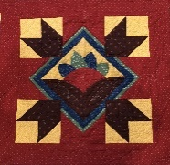
PRAIRIE THREADS
NEWSLETTER OF PRAIRIE PIECEMAKERS
May 2021

Dear Prairie Piecemakers Quilt Guild Members,
Thank you seems insufficient, for all that Susan Williams did for our Guild in the past year. Through her efforts and foresight, to keep the Guild engaged and meeting in one form or another, we are coming out of the Pandemic in great condition. We look forward to your participation in Guild activities in our new program year. It was awesome to have over 50 people at the April face to face meeting.
I am looking forward to serving the coming year as your Guild President. Thank you for your confidence. All members are needed to help with and participate in the projects and activities. There are many exciting and new opportunities as we look forward to celebrating our 40th Anniversary in March 2022. Programs this year will feature six National Speakers, so your dues are a true bargain. Please invite your family and friends to also become active members of the Guild.
Activities will begin on May 24, with “Make It Modern” by Sheila Green, Lincoln. It is a hands-on activity making a traditional block modern. Please bring paper scissors to the meeting. Mary Mayfield from Omaha will present “Tanzanian Treasures” on June 28. You will be able to support their efforts through purchasing fabric. May and June activities will be held at Good Shepherd Lutheran Church beginning at 7:00 p.m. Since they are activities no business meeting. Please see additional activity and meeting opportunities later in the newsletter.
Thank you for participating this past year in our Guild activities. We look forward to seeing you at all activities, workshops, and meetings in the coming year. Please let us know ideas you have for improving our Guild. Please also seriously consider volunteering to share your talents with our Guild. To volunteer please contact Deb Schroeder or Susan Williams.
Deb Schroeder
Prairie Piecemakers Guild Meeting
April 26, 2021
- “What’s New in The Quilting World?” was presented by Susie Brown. Susie updated us on the latest tips, ideas, notions, and quilting fabric trends. Star Bright Workshop was taught by Susie prior to the guild meeting.
- The business meeting was called to order by President Susan Williams at 8:15 P.M.
- A motion was made to approve the minutes from the 11-9-21 guild meeting. Motion seconded and minutes approved as printed in the newsletter.
- Treasurer’s Report-Lisa Braasch: All bills to the guild must be submitted by April 30-end of fiscal year. Treasurer’s report to follow after fiscal year end.
- Sue Arp-Newsletter and Yearbook: Prizes were awarded to Leslie Thompson, Wanda Krueger and Cindy Winters for solving the newsletter puzzle. We will continue with the new yearbook format for 2021-22.
- Challenge Project-Teri Wolfe: The winner of this year’s Challenge Project “Home-Where Your Story Begins” was Deb Schroeder. Deb received a gift certificate to Acme Fabrics donated by Chris Hoffman. All those participating in the challenge project received pin cushions made from the challenge fabric.
- IQM Representative-Kathy Murphy: The museum is now open to visitors.
- Membership-Jill Norenberg: 52 members present with several visitors and new members.
- Retreat-Leslie Thompson: “Bargello-A Rainbow of Color” will be held July 30-31. Registration open to members only at this time. Due to pending sale of Country Traditions, other venues are being explored. Final number of participants may depend on venue options.
- OLD BUSINESS
- Thanks to everyone who participated in our virtual quilt show. Quilt show profit was $6077.50.
- Block of the month with Scott Flanagan continues on our Face Book page. Quilt reveal will be at the October guild meeting.
- Christmas Brown Bag party will be held May 11, 6:30 P.M. at Big Red Keno following current social distancing guidelines. Members not participating in the exchange are encouraged to attend but need to sign up for planning purposes.
- NEW BUSINESS
- The audit committee will meet after fiscal year end. A budget for the year will be presented at the August meeting.
- Deb Schroeder reported the bus trip has been re-scheduled for June 3-4 in 2022. The trip will include stops at Missouri Star and other quilt shops with an overnight stay in St. Joseph. Details and pricing to follow.
- The Steering Committee has voted to change the venue for guild meetings and workshops to First Lutheran Church beginning in August. This change was made to secure better spacing for social distancing concerns as well as sound and lighting improvements plus a cost savings for the guild. A special thanks goes to Sandy and Butch McDuffee for their years of service at Good Shepherd Lutheran Church. We truly appreciated all they’ve done for the guild. Butch and Sandy will receive a gift card to Kayla’s restaurant to thank them for their service.
- Past officers and Steering Committee members were presented a gift in recognition of their service. Susan Williams was presented a beautiful wall hanging made by Deb Schroeder in appreciation for her work as president.
- Election of New Officers: A motion was made, seconded and approved to accept the nominating committee slate of officers: President-Deb Schroeder, Secretary-Jill Norenberg, Treasurer-Lisa Braasch, and Members at large-Danielle Smith and Susan Williams. Mary Lou Carlson has been appointed to be chair of Community Service. Nominees are still being sought for vice-president.
- ANNOUNCEMENTS
- A special thank you to Scott Flanagan for all your work on the BOM project and assistance with all things technology!
- Remaining items from “What’s in the Bag?” and tickets for the batik fat quarter raffle will be sold at the Wolfe Country Quilt Show and Garden Walk July 17.
- 2022 raffle quilt has been pieced by Scott Flanagan, Lisa Braasch, Anita Groh, and Sue Steier. Quilting to be done by Sue Steier. 2022 quilt show chairmen are Pam Schroeder and Teri Wolfe. Venue to be determined.
- A handout was distributed to members listing all quilt guild programs for the coming year.
- Door prizes for those who have renewed their membership were announced.
- Door prizes for those attending were announced by Sue Steier.
- Many lovely quilts and needlework projects were shared at Show and Tell.
- The meeting was adjourned at 9:05 P.M.
Submitted by Pat Mommsen, Secretary.

Prairie Piecemakers Treasurers Report - April 2021
Certificate of Deposit |  | 5,838.38
Checking Account Balance 2/28/2021 |  | 12,846.65
Income:
Membership |  | 1,300.00
Workshops |  | 913.96
Retreat |  | 200.00
What's in the Bag Sale |  | 255.00
Total Income |  | 2,668.96
Expenses:
Deb Schroeder - Heartland Quilt membership |  | 40.00
Secretary of State - Nonprofit biannual report |  | 20.00
Susan Williams |  | 71.46 | Quilt show copies 23.50; Zoom meeting connections - 47.96
Quilt Study Center |  | 350.00 | Donation
Susan Brown |  | 559.00 | Speaker-100.00; Mileage - 179.00; Workshop - 280.00
Good Shepherd |  | 190.00 | Rent
Deb Schroeder |  | 50.00 | Thank you McDuffee's
Sue Arp |  | 77.53 | Newsletter
Sue Arp |  | 310.00 | LuAnn Franzlubber Speaker-100.00; Workshop - 210.00
Total Expense |  | 1,667.99
Ending Balance Checking |  | 13,847.62
Checking & CD Balance at 04/30/2021 |  | 19,686.00
Summary of Quilt Show:
From November 2018 - April 2021
Receipts 2018 - 2020
Raffle Quilt |  | 4,329.00
Silent Auction |  | 730.00
Quilt shops - 10% |  | 1,276.80
What's in the Bag Sale |  | 255.00
Vendors |  | 770.00
Total Receipts |  | 7,360.80
Expenses 2018 - 2020
Vendor Refunds |  | (770.00)
Featured quilter expenses |  | (118.49)
Advertising/Promotions |  | (163.31)
Total Expenses |  | (1,051.80)
Net Profit |  | 6,309.00

STEERING COMMITTEE MEETINGTUESDAY, MAY 11, 2021
First Lutheran Church Conference Room

Our meeting was called to order by President Deb Schroeder at 5 pm.
We started with introductions.
A motion was made and seconded to approve the meeting minutes as they appeared in
our April newsletter. Motion passed
Treasurer Lisa Braasch discussed financial reports as well as tickets for the batik raffle.
Eighty (80) tickets will be made and sold at $5 apiece.
Member at Large Sue Williams discussed the price of programs for the coming year and
handed out forms for our upcoming workshops.
Community Service, Mary Lou Carlson is working on recipients for our donations.
Suggestions included making pot holders for the International Quilt Study Center.
Publicity Carroll Welte – let her know of events that need to be publicized.
Our Quilt Show has been set for October 14th and 15th, 2022 at First Lutheran Church.
We discussed the quilt frames currently in storage and storage being offered by a guild member for storage in Nickerson. Teri Wolfe will speak to Leslie Main as well as Cottonwood Quilt Guild (we share the frames with Cottonwood and have
our quilt shows on opposite years). Teri will have raffle tickets made (at $2 each).
Our retreat is still set for July 30 and 31st but will be at Acme in Blair, NE. Car-pooling
was discussed.
Christmas Challenge is being organized by LuAnn Franzluebbers. Details to follow.
When we are able to serve refreshments again it was suggested that hostesses actually
serve the item(s).
A motion was made and seconded to give First Lutheran Church a $100 free will gift for
hosting the steering meetings that meet monthly at the church. Motion passed.
Marilyn Freeman discussed the Batik Fat-quarter Raffle. Tickets will be sold at Teri
Wolfe’s quilt show with the winner being picked at our August guild meeting.
“What’s in the Bag” has 8 left and will take remaining bags to Teri’s quilt show.
Prizes for early membership was a success and could possibly be done again.
Marketing (Susan Williams) did present information to make business cards as well as
larger hand-outs that include all programs for the year. Motion was made and seconded. Motion passed.
Our bus trip is scheduled for June 3 & 4th, 2022.
Our next Steering Committee meeting will be August 2nd at 6:30 pm at First Lutheran
Church.
Our meeting adjourned at 6:20 pm.

Respectfully submitted,
Jill Norenberg, Secretary

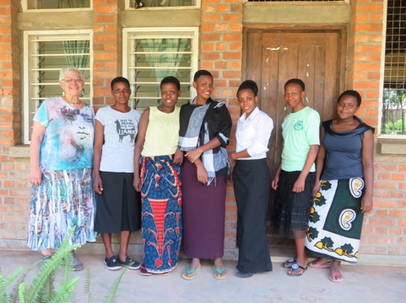
May 24 - Make it Modern with Sheila Green from Lincoln. Hands on summer event. Sheila plans to bring several traditional blocks and show us how to cut them and arrange them into a modern block. Bring a pair of paper scissors and a glue stick. Sheila plans to have a trunk show of her quilts.

June 28 – Tanzanian Treasures – with Mary Mayfield co-coordinator for Tanzanian Treasures, Fabric and More, a Partner Parish Mission Project of St. Matthew Lutheran Church in Omaha, Nebraska. Mary makes quilts and buys and sells African fabric, jewelry, baskets, clothing, artwork, and more.

July 30-31 A Rainbow of Color 2021 Retreat - For those who want to do the retreat project, Sue Steier will be teaching Bargello Quilts. The pattern is included in the workshop fee. You can also work on any project you like.
New location: Acme Fabric and Quilt Co. 1716 Washington St, Blair, NE
Time: July 30 is 9-5, July 31 is 9-4
Limit of 26 including the instructor
Acme will provide a 15% discount on purchases made by attendees during the retreat.
We currently have 20 signed up so there are 6 more slots available.
Everyone who signed up should have received a folder with the Bargello pattern. If anyone didn’t receive the folder ask them to please see me at the May meeting.
Call Leslie Thompson if questions or to register. 402-630-4581 Retreat dates: July 30 & 31st

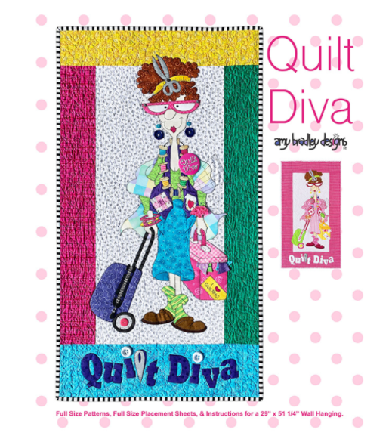
August 30, Amy Bradley “History of a Designer & Trunk Show.
6:30 Gather, 7:00 Program
First Lutheran Church, 3200 East Military
Amy is an extraordinary designer and teacher from Lawrence Kansas. She has a wonderful business built around her unique and humorous caricatures designs. The quilting ladies are popular choices for many applique enthusiasts but you will also love her holiday, animal and special occasion designs. To see Backyard Friends, Monsters and Eat, Sleep Quilt and more Visit https://www.amybradleydesigns.com/

August 31, Applique Amy’s Way will be from 9:30am to 4pm. We are taking sign-up now. Cost $30.00 for members (Non-Members $40.00) Choice of two kits not included in cost. More information later on which kits will be offered. You will love Amy’s class – it is fun!

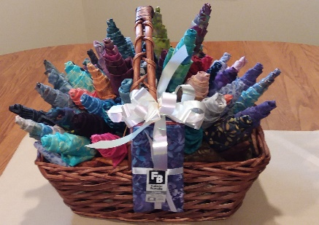
BATIK FAT QUARTER BOUQUET
(Last item from our 2020 Quilt Show)
Only 80 chances will be sold-$5.00 each 80 fat quarters, Approx. 20 yds. of material, 4 patterns included 1 in 80 chance to win.
Chances available at the May and June get-togethers, and at Wolfe’s Quilt show. Drawing at out August meeting.

Quilt Nebraska
Quilt Nebraska will be held in person July 22- 25, 2021 at the Younes Conference Center in Kearney. COVID-19 guidelines will be followed. Theme this year is “Red White, Blue and U”. Registration booklets are available at: www.nsqg.org. Registration assistance is also available by contacting Marty Kleppinger (308) 325-0032 or Barb Hinrichs – (308) 325-0720.

International Quilt Museum Fundraiser
Announcing Friends 2021 Project Potholder

The 2019-20 fundraiser, Project Pincushion, was a huge success, thanks to sewists from around the country. Your contributions were awesome, and brought in much needed funds during a difficult time at the museum. Funds raised from selling potholders in the museum gift shop will once again go toward presenting new and exciting exhibits.
Here are the guidelines for making and donating potholders:
• Make two potholders to be sold as pairs (they do not need to be identical)
• 6” to 10” in size, any shape
• Fabric should be 100% quilt quality cotton
• Batting should be 2 layers of cotton or wool or 1 layer of cotton batting plus 1 layer of insulation such as Insul-Bright©
• Include a hanging loop or ring
Do you have a favorite hot dish recipe? Put it on a 3” x 5” card and include two copies with the potholders. One copy will be set aside for a possible future cookbook.
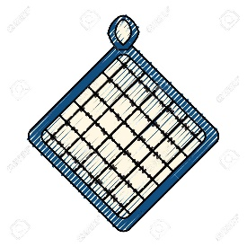
Send your potholder donations to:
Project Potholder
c/o Friends of the International Quilt Museum
1523 N. 33rd Street
Lincoln NE 68583-08380

RENEWAL TIME! The membership form is included with this publication and available directly from me (Anita Groh) if you need extra! Our membership is $20 if paid prior to June 1st MEMBERSHIP and $25 if paid after May 1st. Our guild needs YOU!

PRAIRIE PIECEMAKER MEMBERSHIP FORM 2021-22

Last Name __________________________________________________

First Name __________________________________________________

Address: __________________________________________________

City, State, & Zip __________________________________________________

Preferred Phone __________________________________________________

Email address __________________________________________________

All newsletters will be sent via email to save money and keep our dues the same as previous years. If you have no email, we will send yours via US mail. If you have address labels and can supply them, it makes the mailing process easier.

Guild Opportunities
With COVID (hopefully) coming under control, we hope to return to normal. Your assistance would be most appreciated to be a hostess, a greeter, a quilt holder or bring a door prize to a monthly meeting. Months range from August to April. You may sign up for more than one opportunity.

Hostess: Month(s)

Greeter: Month(s)

Quilt holder: Month(s)

Door prize: Month(s)

Annual dues are $20 IF PAID prior to May 1st. They are $25 if paid after May 1st. Please return completed form to: Anita Groh (Membership Chair) at 1520 N. Hancock Street, Fremont, NE 68025 or Prairie Piecemakers, PO Box 1202, Fremont, NE 68026-1202.

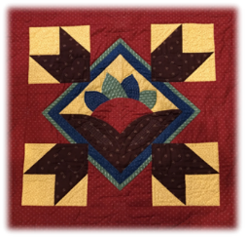
Prairie Piecemakers Fall2021/Winter 2022 Workshop Sign Up Form
I would like to sign up for the following events and workshops:
_________Workshop: Applique Amy’s Way by Amy Bradley (Designer and National Speaker), Tuesday, August 31st 9:30am to 4:00pm at First Lutheran Church, 3200 E Military Ave, Fremont. Cost $30.00 for members (Non-Members $40.00) Choice of two kits not included in cost.

_________Workshop: Mini-Hexified Panel by Elizabeth Granberg-Jerome (National Speaker), Monday, Oct. 25, 1:00 p.m. to 4:00 p.m. First Lutheran Church 3200 E Military Ave Fremont. Tuesday, Oct.26, from 10 am to 3 pm, we will assemble the mini project. Cost: $30 class (Non-Member $40 and $25.00 kit.

_________Workshop: Fall Maple Leaf by Ilene Bartos (Designer and National Speaker), Tuesday Nov, 30, 10:00 a.m. to 4:00 p.m. First Lutheran Church 3200 E Military Ave Fremont. There are 6 different leaf patterns to choose from. You can purchase $10 pattern only, $15 copper wire and/or kit for $46.00 which includes pattern, fabric and copper. Cost: $30 class (Non-Member $40).

_________Workshop: Fabulous Fused Quilts by Robbi Joy Eklow (Designer and National Speaker), Tuesday Feb, 1, 10:00 a.m. to 4:00 p.m. First Lutheran Church 3200 E Military Ave Fremont. The small pattern for the workshop is included in the workshop cost. Cost: $30 class (Non-Member $40).

Check one: Member____ Non-Member____ Prairie Piecemakers Membership Jan. 1- April 30, 2021 $25.00

Amount______________________ Check Number _________________

Name___________________________________________________________

Phone Number____________________________ Cell Phone ________________________

Email Address__________________________________________________________

Please make checks payable to: Prairie Piecemakers and mail with check to: Susan Williams, 7807 N 281st Ave Valley NE 68064. Call to reserve your space in the workshops: Susan (402) 440-7853 or Deb (402)380-2626.

