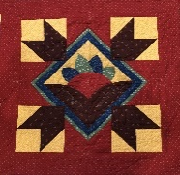
PRAIRIE THREADS
NEWSLETTER OF PRAIRIE PIECEMAKERS May 2020
Hello everyone. I don't know about everyone else but I am looking forward to getting back together with everyone. So sorry we had to once again push the meeting back another month but this is an unusual time.
We are going forward with our planning of the 2020-2021 season and the activities associated with the year. We will probably have to go month to month for a while and adjust accordingly.
Sue has done a very good job with the newsletter, but if ever you have a question of what is going on please do not hesitate to call myself or our next president elect Sue Williams.
May God Bless each and every one of you at this time.
President
Pam Schroeder

1. Next meeting Monday, June 29, 2020 6:30 PM at the Good Shephard Lutheran Church
2. There will be no refreshments.
3. Bring your 2019-2020 challenge projects
4. Speaker: Phyllis Schoenholtz from Ohiowa, Nebraska. Program: Barn Quilts
5. Business Meeting including voting on next year’s officers
6. Awarding the winner of the Challenge Quilt
7. Show and Tell
We are working on a space where we will be able to spread out to be in compliance with the social distancing.

Following is our slate of officers for the coming year. We will vote to approve in June.
New Officers for 2020/21
President- Sue Williams
Vice President- Debra Schroeder
Secretary- Pat Mommsen
Treasurer- Lisa Brasch
Members @ Large: Pam Schroeder. Danielle Smith
Newsletter, Yearbook- Sue Arp
Publicity/Social Media- Colette Garton, Lois Geisler
Membership -Jill Norenberg
Hostess Janet Shamburg
Greeter - Loraine Smith
Door Prizes - Sue Steier
Community Service - Sandy McDuffy
Challenge-Teri Wolf, Pam Schroeder
Retreat Chairman-Loose Threads -Leslie Thompson
IQM representative- Kathy Murphy

Prairie Piecemakers Steering Committee Meeting May 4, 2020
• The meeting was called to order at 6:35 by President Pam Schroeder via Zoom. There were 11 members present.
• Many of our wonderful events have been cancelled or postponed due to the pandemic that is sweeping our country. We have had to figure out creative ways to proceed with our guild activities. We may see different ways of distributing the yearbook due to the uncertainty of our times.
• As of now, the church is closed to everyone until June 1st. Therefore, the May meeting has been cancelled. There is a planned guild meeting on June 29th at the church where we will combine the meetings. Challenge projects will be gathered, displayed and voted on. Phyllis Schoenholz is our presenter on Barn Quilts. Election of officers for the upcoming year and recognition of past officers will take place. There will be no refreshments. However, if a member was scheduled to bring a door prize for one of the missed meetings, they can bring it to the June meeting. We will look into using the gym so we can spread out more for responsible social distancing.
• The next Steering Committee meeting is scheduled for June 22, 2020. Old and new members of the Steering Committee are invited to attend to exchange information on their office. • A committee will be formed to review the treasury books for the 2019/2020 year before the next Steering Committee.
• The programs for next year have been established. Many workshops are scheduled. Sue Williams and Deb Schroeder are still working out all the details.
• A budget committee is being formed for the 2020/2021 year.
• Plans for the Quilt Show in October are still underway. During this time of isolation, members are encouraged to sell quilt raffle tickets via texts and social media.
• The Bus Trip for August is still being planned. A few people needed to cancel due to the date change. However, this date change may open it up to others who previously couldn’t plan on coming.
• Membership for the 2020/2021 year is down significantly. Members are encouraged to mail their dues in to Jill Norenburg prior to June 1st.
• A Christmas themed sit and sew is planned for our guild in July. This will be a very casual event. Everyone will sew on their own projects. Bring a plate of Christmas cookies to share. Just a chance to get together and do what we do best—talk and sew.
• The meeting was adjourned at 7:18 Submitted by Sue Steier, Secretary

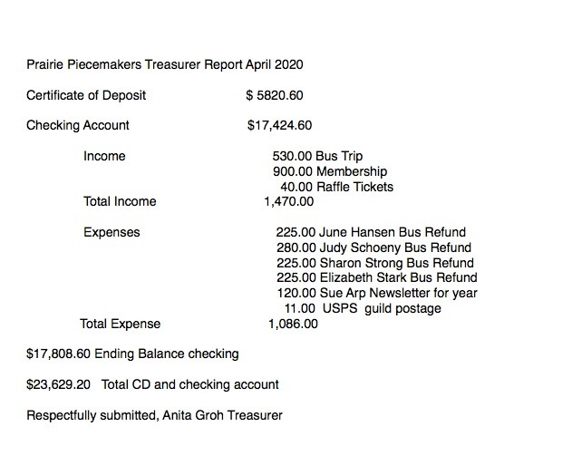Join Your Quilt Club Friends this Summer-
We have several activities planned for this summer. It is always fun to get together with quilting friends. Details on locations and times have changed a little since the last newsletter due to our Covid19 restrictions. Mark your calendar today: Susan Williams

Wolfe Quilt Show and Garden Walk- July 18, 2020 9am-4pm
1709 County Road 21, Bennington, Ne. 68007
Follow us on Facebook@Wolfe Country Quilt Show and Garden Walk
Everyone is welcome to enjoy this FREE event.

July 27, 2020
Christmas in July – Sit and Sew 9AM-8PM Get a head start on your Christmas projects and share ideas with friends. More information to follow. Location Good Shepherd Church.
Aug 7-8, 2020
Star Studded Affair Bus Trip – Guild Bus Tour Rescheduled!!
We invite all Guild members and friends to check their calendar on Friday August 7 and Saturday August 8. Hopefully those that had conflicts with the June dates will be able to join us with the new August dates. By August you will be ready for a fun trip with your Guild friends to Missouri to restock your stash from the sewing you did during the quarantine. Details of the bus tour and registration form are at the end of this newsletter. If you have questions contact Deb Schroeder at 402-380-2626/ dschroeder1@unl.edu or Susan Williams at 402-440-7853 /williamssn1@gmail.com

August 31, 2020 -first meeting of our new year
Trunk Show Anne Wemhoff – will give a Trunk Show at our regular August meeting. Anne is the owner of Calico Annie’s Quilt Show in Fullerton Nebraska.
Workshop – Anne will be teaching a workshop the afternoon of August 31, featuring some of the latest patterns and techniques from her shop. We will have details and sign-up sheets at our May meeting.

The 2020 Star-Studded Quilt Show planning is still underway.

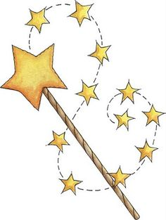
WISH LISTS: Bring your batik fat quarters donations for our quilt show fat quarter basket. We will be collecting them at our next in-person gatherings. Julie Joyce

WHAT’S IN THE BAG WISH LIST:
See through bags will contain either a precut, or three yards of coordinating fabrics. Just like the fishing pole game at carnivals, there will be a fun surprise hidden in each bag with the material. It could be a pattern, a notion, an embellishment, etc.
Donations will be accepted at the June, July, and August guild events. Thank you. If you need more information or have questions, call Pat Mommsen, 402-625-2109 or 402-669-9119.

Charm Packs-two of a kind
Jelly rolls
Layer Cakes
Yardages: one-yard cuts of the following
Patriotic Prints
Christmas Prints
Halloween Prints
Autumn Prints
Batiks
Red and White Prints
Blue and White Prints
Black and White Prints
Modern Prints
Blenders
Neutrals
Notions: Pins, tape measures, marking pens, small rulers, etc.
Embellishments: Fun Buttons, rick rack, etc.

Items are starting to be collected for the Silent Auction. We already have two sets of embroidered tea towels by Edith, a set of chair rollers that can be added to any chair, a hand turned stylus. Contact Marilyn Bonow or Jill Norenberg, if questions or donations.
PRAIRIE PIECEMAKER MEMBERSHIP FORM 2020-2021
Last Name: ______________________________________________
First Name: ______________________________________________
Address: ______________________________________________
City, State, Zip: ______________________________________________
Preferred Phone: ______________________________________________
Email address: ______________________________________________
All newsletters will be sent via email to save money and keep our dues the same as previous years. If you have no email, we will send via mail. If you have address labels and can supply, it makes the mailing process easier.

Guild Opportunities: Be a hostess, a greeter, a quilt holder or bring a door prize. Please list the month(s) you would like to serve. Months range from August to April. You may sign up for more than one opportunity.
Hostess: Month(s):
Greeter: Month(s):
Quilt holder: Month(s):
Door Prize: Month(s):

Annual dues are $20.00 if paid prior to May 31st.
They are $25.00 if paid after May 31st.
Return completed form to:
Jill Norenberg, membership chairman, at 2506 East 10th St. Fremont, Ne. 68025 or
Prairie Piecemakers. P.O. Box 1202, Fremont, Ne. 68026-1202

Star Studded Adventure
Friday, August 7 - Saturday, August 8, 2020

Plan to join guild members for a fun Star-Studded Adventure to Missouri! Friday’s bus tour highlight will be an MSQC Sewing experience and shopping at Missouri Star Quilt Company, in Hamilton, MO. Bring patterns and samples to match during a three-hour shopping spree at Missouri Quilt Company stores. We have a fun program planned for you Friday evening in St Joe.
Tour stops on Saturday will include: Top Stitch Quilt Shop, Helena, MO; Crossroads Quilting, Cameron, MO; and Needles I in Auburn NE.
For more details contact Susan Williams, williamssn1@gmail.com, 402-440-7853 or Deb Schroeder, dschroeder1@unl.edu, 402-380-2626.
Tour Price Includes:
- Deluxe motor coach
- Professional driver
- Snacks and Prizes
- 5 meals
- Hotel Lodging
- Taxes and Tips
- MSQC and 3 Quilt Shops

Per Person Price Double Occupancy Club Members:

Member price after April 1 - $250.00
Non-club member price after April 1 - $280.00
Per Person Price Single Occupancy: add $70.00

Cancellation Policy: Fees are refundable until May 1, 2020. The refundable amount is reduced by prepaid items such as hotel, tickets, bus and meals.
Reservation Form
Name_________________________________________Address______________________
Phone_______________________________CellPhone______________________________
E-mail_____________________________Rooming with_____________________________
Amount enclosed _____________________ Checks: Payable to Prairie Piecemakers
I have read, understand and agree to cancellation penalties.
________________________________________________Signed_________________Date
Prairie Piecemakers Quilt and Needlework Guild
Bus Tour Health Form
(The following information is held in strictest confidence.)

Please complete this information and return it with your reservation and check.

Name_____________________________________ Home Phone____________________________

Cell Phone__________________________________ Address________________________________

List any medical conditions (past or present) that could possibly cause a concern during your trip.

List all medications and any allergies to medications.

Doctors Name & Telephone number:____________________________________________________

Insurance carriers: ______________________________________________________________

Emergency Contact
Name:_________________________ Day Phone____________ Evening Phone ____________________ Cell______________________

Name:_________________________ Day Phone____________ Evening Phone ____________________ Cell______________________

I understand that if I need assistance with individual needs such as walking, dinning, getting on or off Motor coaches and other transportation that I must be accompanied by a qualified companion who will assist me with these needs. I understand that if I become sick or are injured and need medical attention that I will be responsible for related expenses and travel home. I assume all risk of personal injury, sickness, death, damage and expenses as result of participation in this event. I agree to hold the representatives of Prairie Piecemakers harmless without limit from all liability or claims from damages and injury arising while participating in this event.
Signature____________________________________________ Date_______________________________

