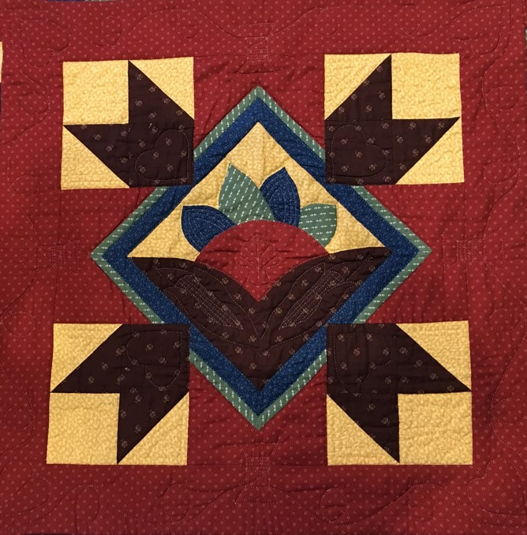
Prairie Piecemakers
June Update 2020

Flexibility is the Key Word for 2020
Details on locations and times have changed a little since the last newsletter due to newer Covid19 restrictions and the change of hours at Country Traditions. What hasn’t changed is our desire to have a great time when we get together! Sue Williams

Summer Event
Monday, June 29, 2020 Good Shepherd Church Gym 6:45 pm

We will meet in the gym at Good Shepherd Church.
- Please arrive between 6:45 and 7:00 pm
- Please enter through the East door (just like you would for the Quilt Show).
- Our chairs will be 6 feet apart. Social distancing is very important.
- Please wear your face masks.
- Do not attend if you do not feel well.
- No food or drink will be served.
- Bring your Challenge Project and your Show and Tell Projects.
- Bring your fat quarter donation for the Batik Fat Quarter Basket for the Quilt Show
- Bring your Raffle Ticket Stubs.
- Pick up bus ticket refund check and health information.
- Sign up for Fall Workshops.
- We will have a Program, Challenge Project Voting, Officer Election/Installation and Show and Tell.
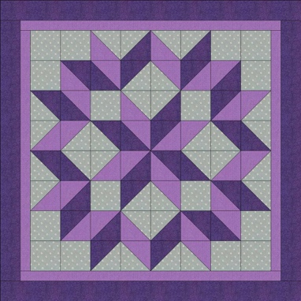
Program – Barn Quilting – Phyllis Schoenholz, retired UNL Extension Educator has a passion to help others realize the satisfaction that comes from “Service Learning”. She is South Central Nebraska Coordinator for Quilts of Valor. She partners with Nebraska 4-H to help youth give back as they make and award Quilts of Valor to veterans. Phyllis taught Barn Quilt classes during her Nebraska Extension profession and during retirement. She continued giving back to her community through teaching and fund-raising via Barn Quilts during the 2018 Cattlemen’s Ball with proceeds going to UNMC cancer research. In 2019, working with Pam Hoge of Hubbell, Phyllis and volunteers distributed over 500 “Quilts for Our Heartland” to flood survivors in Nebraska.

Wolfe Quilt Show and Garden Walk
July 18 2020 9am – 4pm
1709 County Road 21, Bennington, NE 68007
Facebook @Wolfe Country Quilt Show and Garden Walk. Enjoy this Free event.
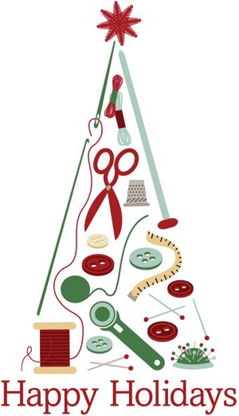
Christmas in July Sit and Sew
Thursday, July 30, 2020 at 9am to 8pm
Country Traditions
Get a head start on your Christmas projects and share ideas with friends. Bring your projects, a sack lunch and a dozen cookies to share. Have any Christmas fabric you would like to exchange? Bring your fabric to trade with others. Plan to stay through the evening meal and everyone will pitch in $3.00 for pizza. We will have a show and tell session at 6:30 pm. Please bring holiday items to share. The event will be from 9 am to 8 pm at Country Tradition. We will be limited to the first 25 people who sign up. Our numbers may change depending on the Health Restrictions announced July 1. (Note the Date and Location Change)

Star Studded Affair Bus Trip
Star Studded Affair Bus Trip is cancelled. Missouri Star Quilt Company will not be allowing buses to come to their location because of the spread of COVID- 19. We will be refunding your money.

August 31, 2020 6:30 pm Good Shepherd Church
Program: Latest Trends and Trunk Show Anne Wemhoff will give a Trunk Show at our regular August meeting. She will be featuring some of the latest patterns and techniques from her shop. Anne always dreamed of having a quilt shop, so in 1999 when the last child left the nest, she and her husband Arnie decided the time was right. With the help of some friends (including Rhonda), Anne and Arnie cleaned decades of dirt and grime from the old hardware store, added some modern electricity, lighting, and plumbing. Lo and behold - they morphed into Calico Annie and Calico Arnie!

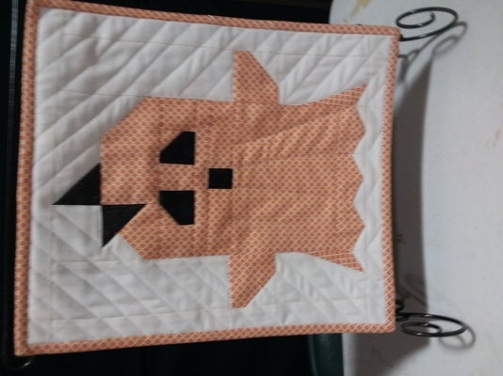
Workshop: BOO! Anne will be teaching a workshop the afternoon of August 31, from 1pm to 4pm at Country Traditions. You will be making this cute ghost pattern that everyone seems to love! During the workshop you will learn a clever way to do points without a special ruler. Anne will supply the fabric and pattern for this table decoration. She will be showing you the design made into a wall hanging with 9 Ghosts. The pattern could even be made into a large quilt. Get in the mood for fall working with Anne this special project. Cost $30.00 includes the pattern and fabric.

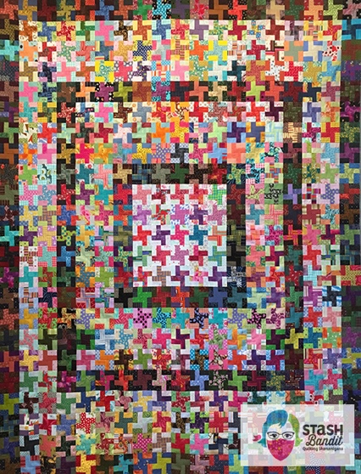
September 28, 2020 6:30 Good Shepherd Church
Program: Make Extraordinary Scrap Quilts Diane Volk Harris is a National Presenter from Bladan NE. She is a quilter, speaker, teacher and designer of scrap quilts made from stash. After 11 years as an editor for Quiltmaker Magazine, she formed Stash Bandit. She is passionate about making scrap quilts and creating interesting original designs. Her work has been featured in American Patchwork & Quilting, Quiltmaker, McCall’s Quilting, Quick Quilts and Modern Patchwork. How do you make a successful scrap quilt? Learn Diane’s best tips and a few secrets during this trunk show of more than 50 scrappy quilts made over many years. What is a scrap quilt? Who can make a scrap quilt? Why would you create one? How is it done? Discover ways to pull your scraps together, strategies for using your stash and even what does not work. You may never make an ordinary quilt again! You can see her work on her website https://stashbandit.net/ .

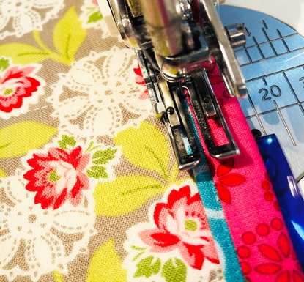
Workshop: Bound for Glory Do you dread binding a quilt? Do your edges give you less than a fine finish? Solve all your binding woes here! You will enjoy learning as Diane Volk Harris teaches unique ways to finish your quilts. Learn the hints, tips and tricks to perfect binding every time. We’ll cover everything from cutting to bias to corners and even show you a mock-hand binding done completely by machine. You’ll never balk at binding again! (Cost $40.00).

Slate of Officers for 2020-2021
President – Sue Williams
Vice President – Debra Schroeder
Secretary- Pat Mommsen
Treasurer – Lisa Braasch
Member at Large: Pam Schroeder
Member at Large: Danielle Smith

2020-2021 Committee Chairmen
Newsletter/Yearbook – Sue Arp
Publicity/Social Media – Colette Garton, Lois Geisler
Membership – Jill Norenberg
Hostess – Janet Shamburg
Greeters Lorine Smith
Community Service – Sandy McDuffy
Challenge Project – Teri Wolf & Pam Schroeder
Retreat Chairman – Leslie Thompson & Loose Threads
IQM Representative – Kathy Murphy
Quilt Show – Marilyn Freeman & Sue Arp

